 | EUROPEAN COMMISSION  DIRECTORATE-GENERAL  INFORMATICS  Information Systems Directorate

European Commission
CIPADMIN Use Case Specification:
UC0060 - e-TrustEx Admin Console - Manage Documents

Date: | 20/01/201716/09/2014
Version: | 21.000000
Authors: | Anamaria BATRINU
Revised by: | Sandro D'ORAZIO, Maarten DANIELS
Approved by:
Public:
Reference Number:
TABLE OF CONTENTS
1. Use-Case Description 5
1.1. Primary Actor 5
1.2. Definitions, Acronyms and Abbreviations 6
1.3. References 6
1.4. Context Diagram 7
1.4.1. CIPA Administration Console 7
1.4.2. Manage Document module 8
2. Flow of events 8
2.1. Basic Creation Flow 8
2.1.1. User chooses the Create Document menu action 8
2.1.2. System displays the "Create Document" page 8
2.1.3. User enters information 8
2.1.4. System creates the Document 9
2.1.5. User acknowledges and closes the confirmation Popup 9
2.1.6. System redisplays the saved document in view mode 9
2.1.7. The basic creation flow ends. 9
2.2. Basic search flow 10
2.2.1. User selects the Search Document menu action 10
2.2.2. System displays the "Search Document" page 10
2.2.3. User enters the search criteria 10
2.2.4. The System searches the documents 10
2.2.5. System displays the documents found 10
2.2.6. User views the result list 11
2.2.7. The basic search flow ends. 11
2.3. Basic Visualization Flow 11
2.3.1. At 2.2.6, User clicks a Document in the list 11
2.3.2. System opens the document visualization page (see 7.3."View Document" page): 11
2.3.3. User visualises the details of the document: 11
2.3.4. Visualization flow ends. 11
2.4. Basic Modification Flow 11
2.4.1. At 2.3.3., User chooses to edit a Document 11
2.4.2. System opens the Document page in edit mode (see 7.4."Modify Document" page): 11
2.4.3. User makes the changes 12
2.4.4. The system saves the modified Document 12
2.4.5. User acknowledges and closes the confirmation Popup 12
2.4.6. System redisplays the document in view mode (see 7.3."View Document" page) 12
2.4.7. The Modification flow ends. 12
2.5. Basic Deletion Flow 12
2.5.1. At 2.3.3., User chooses to delete a Document 12
2.5.2. System displays a dialog window asking for deletion confirmation 12
2.5.3. User confirms the deletion 12
2.5.4. System deletes the document 13
2.5.5. System notifies user of the success of the operation 13
2.5.6. User acknowledges the message 13
2.5.7. The Deletion Flow ends. 13
2.6. Alternative Flows 13
2.6.1. AC1: at step 2.1.3., User chooses Cancel option 13
2.6.2. AC2: at step 2.1.3, User chooses Clear option 13
2.6.3. AC3: at step 2.1.4, Business Rules are not verified 13
2.6.4. AS1: at step 2.2.4, no document found for the specified criteria 13
2.6.5. AM1: at step 2.4.3, User chooses Cancel option 13
2.6.6. AM2: at step 2.4.3, User chooses Reset option 13
2.7. Exceptional Flows 14
2.7.1. E1: at steps 2.1.1, 2.2.1, 2.3.1, 2.4.1 and 2.5.1 user is not authorized for the operation 14
3. Special Requirements 14
3.1. Interface(s) with other Systems 14
3.2. Security Requirements 14
3.3. Other Special Requirement 14
4. Preconditions 14
5. Post conditions 14
6. Additional Information 14
6.1. Includes 14
6.2. Extends 14
7. Mock-up screens 15
7.1. "Create Document" page 15
7.2. "Search Document" page 15
7.3. "View Document" page 15
7.4. "Modify Document" page 16
7.5. "Delete Document" page 16

Document History

Version | Date | Comment | Modified Pages
0.001 | 03/10/2013 | First draft | All
0.002 | 10/04/2014 | Changes mostly related to using consistency regarding mockup buttons and their functionality. Updated Search business rules. | Where needed
0.003 | 10/06/2014 | Added business rules (max length of fields, trimming of leading and trailing spaces, one mandatory search field, etc.). Business rules renumbering. | Sections 2.1, 2.2 and 2.4
0.004 | 17/09/2014 | Added UC60_BR09 (field min length = 2 chars)
0.005 | 03/10/2014 | Added exception for UC60_BR09
0.006 | 14/10/2014 | Field maximum length has been changed from 250 to 255 characters.
0.007 | 15/10/2014 | Removed specific messages (quoted ones) to allow more flexibility.
1.000 | 04/11/2014 | - CIPADMIN-243 (mockup labels)  - CIPADMIN-279 (logging)  - Added search popup behaviour | - Section 7  - where needed  - Sub section 2.2.6
1.001 | 11/12/2014 | CIPADMIN-267: Support user role  Diagrams update
1.002 | 26/01/2015 | CIPADMIN-264: Ordered lists | Section 2.2.5
1.003 | 26/10/2016 | ETRUSTEX-1392
2.000 | 20/01/2017 | ETRUSTEX-1937: Reorganizing CIPAdmin user roles

Use-Case Description
This use case depicts the sequence of actions that a user needs in order to create a Document, by providing the document type and other characteristics for a document exchanged in the context of the Profile (e.g. Invoice documents). It also describes the management actions that correspond to a created Document, such as Update, Delete, View and Search.
The "Document Management" service is exposed on the CIPAdmin module of e-Trustex platform.
In the remainder of the document the CIPADMIN application will be referred to as the System.

Primary Actor
A humain user can access the Manage Document feature via CIPAdmin interface.
For detailed user access rights on each feature option, please see UC 0100 - eTrustEx Admin Console - Authenticate and Authorise User, section 6.3 User Access Rights.
In the remainder of the document, the user will be reffered to as User.

Definitions, Acronyms and Abbreviations
Acronym, Abbreviation or Definition | Explanation
CIPA | Common Infrastructure for Public Administrations
CIPADMIN | CIPA AdminConsole
ADM | A user having General Administrator role. The General Administrator is the Administrator of the CIPAdmin application.
CBO | A user having Central Business Owner role. The Central Business Owner is responsible for the organization and operation of a business domain and uses CIPA in his business context.
UC(s) | Use Case(s)

References
Ref. | Reference | Title / description | Version | Date
[R1] | CIPADMIN-VISION | CIPADMIN Vision document | V.61-EN | 18/04/2013

Context Diagram

CIPA Administration Console
The diagram below depicts all the Services available on the CIPA Administration Console for e-TrustEx platform. Depending on the user role, only a subset of those services is exposed on the e-TrustEx Administration Console home page.
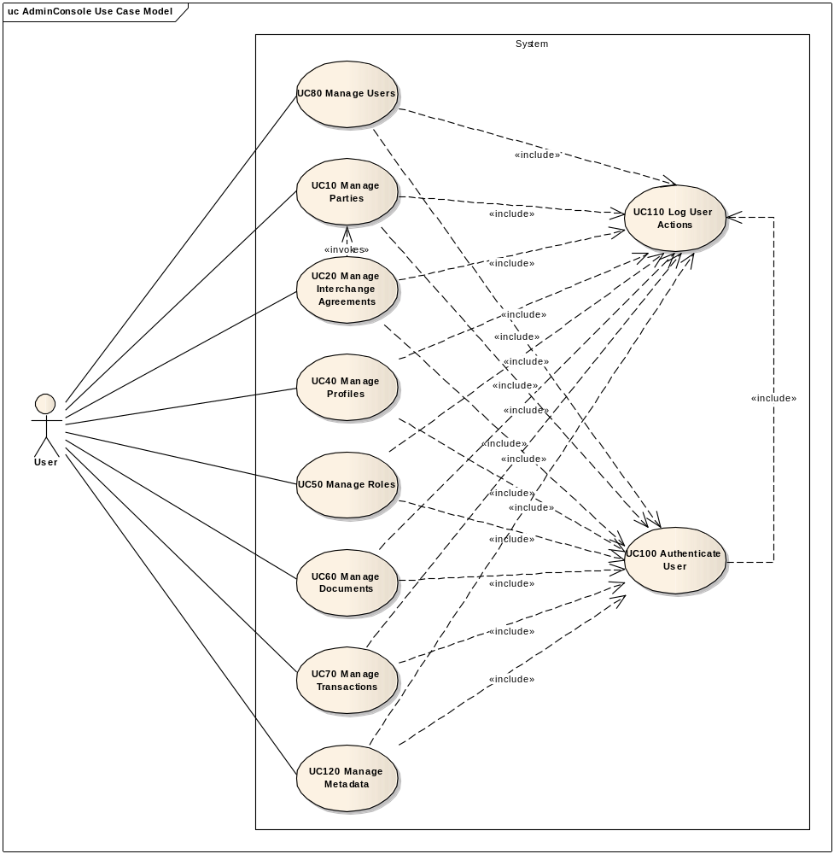

Manage Document module
The diagram below depicts how this use case interacts with other use cases implemented in the Administration Console.
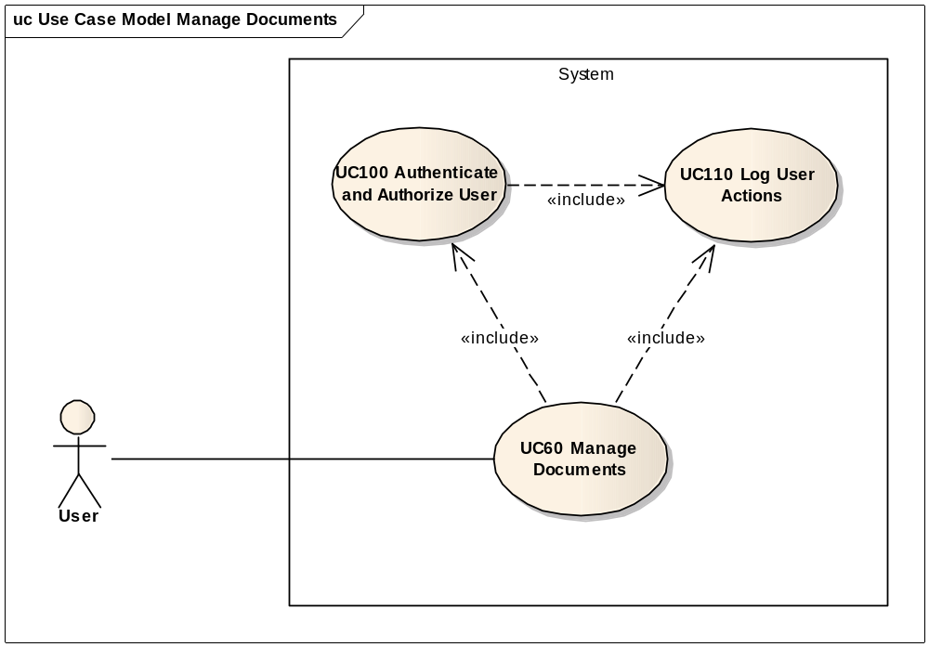

Flow of events
The conventions described in User Interface Generic Conventions document must be applied.

Basic Creation Flow

User chooses the Create Document menu action
ID | Description
UC60_BR01 | User needs to have the correct access rights in order to access this feature. Please see UC 0100 - eTrustEx Admin Console - Authenticate and Authorise User, section 6.3 User Access Rights for more information.
User selects Technical Configuration > Document > Create from e-TrustEx Administration Console home page.

System displays the "Create Document" page
The System displays the 'Create Document' page as described in paragraph 7.1. "Create Document" page.

User enters information
- User fills in the fields:
  - Document name
  - Document namespace
  - Document type code
  - Version
  - Local name
- User chooses save option.

System creates the Document
ID | Description
UC60_BR02 | Document name is mandatory.  If not filled id, notify user that the document name must not be empty or spaces.
UC60_BR03 | Document local name is mandatory.  If not filled id, notify user that the document local name must not be empty or spaces.
UC60_BR04 | Document local name is defaulted to document name.
UC60_BR05 | Document namespace is mandatory.  If not filled id, notify user that document namespace must not be empty or spaces.
UC60_BR06 | Document type code is mandatory.  If not filled id, notify user that the document type code must not be empty or spaces.
UC60_BR07 | All fields shall have at most 255 characters.
UC60_BR08 | When saving the fields, the leading and trailing spaces are ignored. This rule shall be applied before verifying UC60_BR07 and UC60_09.
UC60_BR09 | All fields, except the document version, shall have at least 2 characters.

- System validates the page according to the business rules.
- System saves the Document.
- System logs the successful creation: include use case Log CIPAdmin User Actions
- System informs the user about the success of the operation

User acknowledges and closes the confirmation Popup

System redisplays the saved document in view mode
- System goes to step 2.3.2 in "2.3. Basic View Flow".

The basic creation flow ends.

Basic search flow

User selects the Search Document menu action
ID | Description
UC60_BR01 | User needs to have the correct access rights in order to access this feature. Please see UC 0100 - eTrustEx Admin Console - Authenticate and Authorise User, section 6.3 User Access Rights for more information.
User selects Technical Configuration > Document > Search from e-TrustEx Administration Console home page.

System displays the "Search Document" page
System displays the search page as described in paragraph 7.2. "Search Document" page.

User enters the search criteria
- User enters one or more search criteria. A search criterion left empty means the concerned field will not be taken into account. The user can search by:
    - Document name
    - Document local name
    - Document type code
- User activates the search button.

The System searches the documents
ID | Description
UC60_BR10 | A field left empty or containing only spaces is not taken into account during the search.
UC60_BR11 | Character case is ignored.
UC60_BR12 | Trailing and leading spaces are ignored.
UC60_BR13 | Field value can contain a partial match.
UC60_BR14 | At least one search field should be filled in.
UC60_BR15 | If a single search field is filled in, it needs to contain at least 2 characters.
The system searches the documents that satisfy all the entered criteria.

System displays the documents found
The system displays the list of documents coresponding to the search criteria, showing the following information:
  - Document name
  - Document type code
  - Document namespace
  - Document version
The results list is ordered by document name in ascendant alphabetical order and ignoring case.

User views the result list
- By clicking on the document name in the list, User can
  - view the details of a document (see 2.3. Basic Visualization Flow), if the search flow has been started from the application menu
  - or, if called from another use case, select the document and return it to the caller use case
- User can launch a new search

The basic search flow ends.

Basic Visualization Flow
ID | Description
UC60_BR01 | User needs to have the correct access rights in order to access this feature. Please see UC 0100 - eTrustEx Admin Console - Authenticate and Authorise User, section 6.3 User Access Rights for more information.

At 2.2.6, User clicks a Document in the list

System opens the document visualization page (see 7.3."View Document" page):
- System reads the data
- System loads data on screen
- All fields are protected
- "Cancel", "Edit" and "Delete" buttons are made available

User visualises the details of the document:
- User can return to the result list by choosing "Cancel", the view flow ends and basic search flow restarts at 2.2.6
- User can choose to edit or to delete a Document (see 2.4 Basic Modification Flow and 2.5. Basic Deletion Flow)

Visualization flow ends.

Basic Modification Flow
ID | Description
UC60_BR01 | User needs to have the correct access rights in order to access this feature. Please see UC 0100 - eTrustEx Admin Console - Authenticate and Authorise User, section 6.3 User Access Rights for more information.

At 2.3.3., User chooses to edit a Document

System opens the Document page in edit mode (see 7.4."Modify Document" page):
ID | Description
UC60_BR16 | Document name is read-only.
- The document name is protected;
- All other fields can be modified;
- "Cancel", "Reset" and "Save" options are present.

User makes the changes
- User makes the desired changes
- User chooses the save option

The system saves the modified Document
ID | Description
UC60_BR07 | All fields shall have at most 255 characters.
UC60_BR08 | When saving the fields, the leading and trailing spaces are ignored. This rule shall be applied before verifying UC60_BR07 and UC60_BR09.
UC60_BR09 | All fields, except the document version, shall have at least 2 characters.
UC60_BR18 | User is always notified of the success of the operation: "Document successfully saved".
- The system validates the page according to the business rules.
- The system saves the Document.
- System logs the successful modification: include use case Log CIPAdmin User Actions
- The System informs the user about the success of the operation

User acknowledges and closes the confirmation Popup

System redisplays the document in view mode (see 7.3."View Document" page)

The Modification flow ends.

Basic Deletion Flow
ID | Description
UC60_BR01 | User needs to have the correct access rights in order to access this feature. Please see UC 0100 - eTrustEx Admin Console - Authenticate and Authorise User, section 6.3 User Access Rights for more information.
UC60_BR20 | Document cannot be deleted if it is used in a transaction.

At 2.3.3., User chooses to delete a Document

System displays a dialog window asking for deletion confirmation

User confirms the deletion
If user chooses to cancel the deletion, he is returned to the visualization page (2.3.3.).

System deletes the document
- System verifies the business rules
- System deletes document
- System logs the successful deletion: include use case Log CIPAdmin User Actions

System notifies user of the success of the operation

User acknowledges the message

The Deletion Flow ends.

Alternative Flows

AC1: at step 2.1.3., User chooses Cancel option
- System disregards all information provided by User
- System closes the page
- System redirects the user to CIPAdmin home page

AC2: at step 2.1.3, User chooses Clear option
- Systems disregards all information provided by the user
- Alternate flow ends and basic creation flow restarts at 2.1.2.

AC3: at step 2.1.4, Business Rules are not verified
- System logs the error: include use case Log CIPAdmin User Actions
- The system highlights the field(s) in error
- The System displays the error messages.
- Alternate flow ends and basic flow restarts at 2.1.3.

AS1: at step 2.2.4, no document found for the specified criteria
- System logs the error: include use case Log CIPAdmin User Actions
- The system notifies the user that no document has been found
- Alternate flow ends and basic search flow restarts at 2.2.3

AM1: at step 2.4.3, User chooses Cancel option
- System disregards all information provided by User
- System closes the page
- Alternate flow ends and basic flow restarts at 2.3.2 (visualization page).

AM2: at step 2.4.3, User chooses Reset option
- Systems disregards all information provided by the user
- Alternate flow ends and basic modification flow restarts at 2.4.2.

Exceptional Flows

E1: at steps 2.1.1, 2.2.1, 2.3.1, 2.4.1 and 2.5.1 user is not authorized for the operation
Include the steps in section 2.4.1 of Authenticate and Authorise User Use Case.

Special Requirements

Interface(s) with other Systems

Security Requirements

Other Special Requirement

Preconditions
- User must be registered user of CIPAdmin tool
- User must be logged in & successfully authenticated on the e-TrustEx Admin Console

Post conditions
- [Success] The Document has been successfully created / modified / deleted.
- [Failure] The System logs the failure reason and the context, the use case is aborted and the primary actor has been notified of the reasons.

Additional Information

Includes
- For operation authorization: UC 0100 - eTrustEx Admin Console - Authenticate and Authorise User
- For logging: UC 0110 - eTrustEx Admin Console - Log CIPAdmin User Actions

Extends

Mock-up screens

"Create Document" page
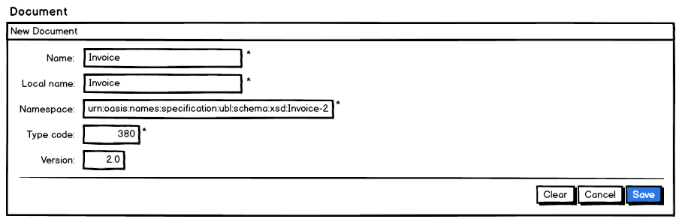

"Search Document" page
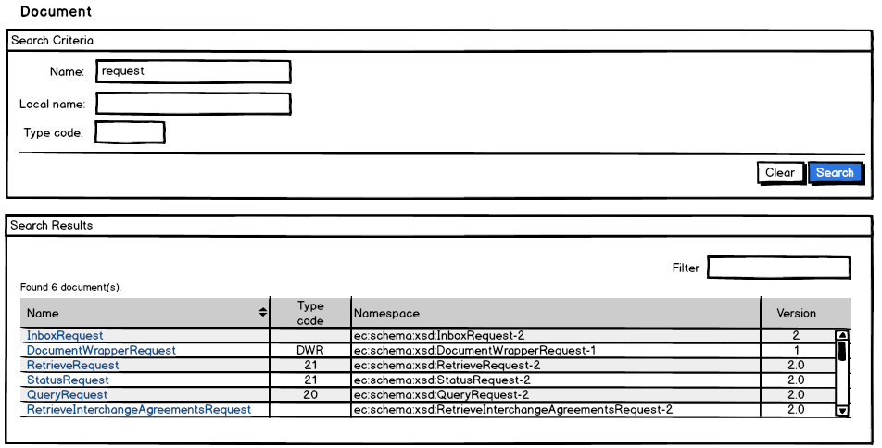

"View Document" page
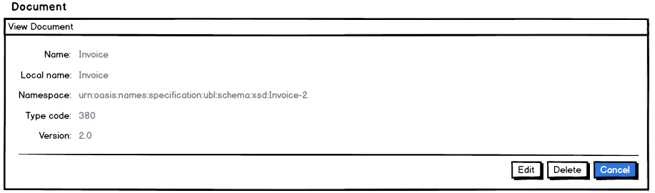

"Modify Document" page
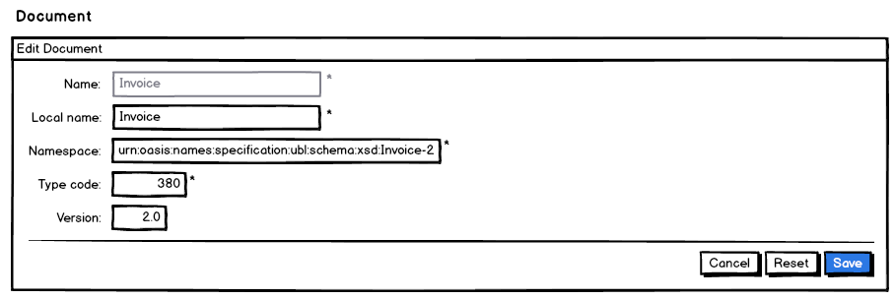

"Delete Document" page
